MCI bayesian analysis methods and results
Lauren Cassidy
2023-05-13

Analysis methods
We investigated if the monkeys exhibited a preference for one of the tasks displayed during the Multiple Choice Interface experiment using a Bayesian generalized linear mixed model (GLMM). We fit the Bayesian GLMM with a logit-link function and the family specified as ‘categorical’ as there were three possible tasks the monkeys could choose from (picture, static, or dynamic task; the picture task was the reference category for the model). We included choice position (left, middle, or right), time of day, and session as predictors in the model to account for the monkeys’ hand preferences, variation in engagement across the day, and development of preferences over time, respectively. We checked all variables for correlations (Pearson correlation coefficients below 0.5). Additionally, we checked the distributions of model covariates (time of day, session) and z-transformed these predictors to a mean of 0 and a standard deviation of 1 to provide more comparable estimates (Aiken et al., 1991; Schielzeth, 2010). As random effects, we included monkey identity, the group identity, and day into the model with all possible random slopes to keep type I error rates at the nominal level of 0.05 (Barr et al., 2013; Schielzeth and Forstmeier, 2009).
We analyzed our data using the ‘brms’ package (version 2.16.3: Bürkner, 2017) in R (version 4.1.2: R Core Team, 2021). brms calls on Stan, a computational framework, to fit Bayesian models (Bürkner, 2017). Each model was run using four MCMC chains for 2500 iterations, including 1000 “warm-up” iterations for each chain. We checked convergence diagnostics for each model, finding there were no divergent transitions, that all Rhat values were equal to 1.00, and that visual inspection of the plotted chains confirmed convergence. We used weakly informative priors to improve convergence, avoid overfitting, and to regularize parameter estimates (McElreath, 2020). The prior for each intercept was a normal distribution with a mean of zero and a standard deviation of 1. For the beta coefficients, we used a prior with a normal distribution with a mean of 0 and a standard deviation of 0.5. For the standard deviation of group level (random) effects, we used a prior with an exponential distribution with scale parameter 1. Lastly, we used a LKJ Cholesky prior with scale parameter 2 for the correlations between random slopes.
Model estimates are reported as the mean of the posterior distribution with 95 % credible intervals (CI). We calculated the proportion of posterior samples that fell on the same side of 0 as the mean (Pr) to aid in the interpretation of whether the predictor variables substantially affected choice or trial outcome behavior. As the Pr ranges from 0.5 to 1.0, a Pr of 1.0 indicates the direction (negative or positive) of a predictor’s effect, whereas a Pr of 0.5 indicates an effect centered around 0 (i.e., no effect on response variable).

Analysis results
We determined if adult male rhesus macaques exhibited task preferences in a Multiple Choice Interface experiment. In our Multiple Choice Interface experiment, group- or pair-housed monkeys were presented with a choice between three stimuli associated with viewing a picture (i.e., “picture task”), touch a stationary stimulus (i.e., “static task”), and touching a moving stimulus (i.e., “dynamic task”). The static and dynamic tasks were rewarded with a small juice reward for touching the stimulus correctly. Overall, we conducted five to six sessions per social group (two to four adult male rhesus macaques), resulting in 68118 trials over XX hours of exposure to the Multiple Choice Interface (see Table 1 for the descriptive statistics per monkey).
Table 1: Average number of trials (± standard deviation) each task was selected per monkey over sessions of the Multiple Choice Interface experiment.
Group ID | Monkey ID | No. of  sessions | Pictures | Static | Dynamic
A | alw | 6 | 70.17 ± 47.47 | 2132.17 ± 809.22 | 331.67 ± 363.15
 | cla | 6 | 145.17 ± 89.28 | 189 ± 106.07 | 132.83 ± 98.5
B | bac | 5 | 64.8 ± 41.98 | 369.6 ± 86.3 | 247.2 ± 166.89
 | nil | 5 | 79.4 ± 53 | 175.8 ± 88.9 | 155.8 ± 64.98
C | cas | 6 | 84.17 ± 38.7 | 407.33 ± 201.79 | 211.5 ± 124.8
 | ear | 6 | 82.17 ± 61.41 | 592.33 ± 379.9 | 226 ± 136.8
D | cur | 5 | 24.8 ± 19.74 | 67.8 ± 72.73 | 13.75 ± 12.28
 | pin | 5 | 20.4 ± 4.67 | 172.2 ± 63.37 | 31.2 ± 7.79
E | der | 6 | 177.33 ± 192.57 | 896.17 ± 503.14 | 153 ± 130.18
 | elm | 6 | 52.5 ± 72.45 | 1408.67 ± 415.48 | 88 ± 90.01
F | nat | 6 | 64.83 ± 49.93 | 151.67 ± 174.41 | 89.4 ± 95.68
 | vin | 6 | 45.17 ± 68.61 | 487.67 ± 307.17 | 90.83 ± 108.41
G | hei | 6 | 101 ± 49.39 | 506.83 ± 282.14 | 92.67 ± 55.02
 | lot | 6 | 239.17 ± 104.42 | 213.83 ± 90.84 | 223.17 ± 108.37
 | pan | 6 | 88.67 ± 26.24 | 95.17 ± 61.04 | 46.17 ± 27.82
 | san | 6 | 22.83 ± 10.11 | 83.17 ± 44.6 | 176.83 ± 57.15

Overall, we found strong evidence that the monkeys preferred the static task over the picture and dynamic tasks (Table 2; Fig. 1), with evidence of individual preferences (Fig. 2). Additionally, we found strong evidence that the monkeys became more likely to select the static task over additional sessions of the Multiple Choice Interface experiment (Table 2; Fig. 3). Interestingly, the position of each task stimulus did not substantially influence the monkey’s probability to select the static task but had an effect when the monkeys’ selected the picture or dynamic task (Table 2; Fig. 4). Generally, the monkeys were more likely to select the picture task when the stimulus was positioned on the right and more likely to select the dynamic task when the stimulus was positioned in the middle (Fig. 4). We found little evidence that time of day influenced when the monkeys’ engaged with the Multiple Choice Interface (Table 2).
Table 2: Output of the Bayesian generalized linear mixed model investigating task preference during the Multiple Choice Interface experiment.
 | Estimate | SD | Lower CI | Upper CI | Pr
Dynamic
Intercept | 0.39 | 0.29 | -0.19 | 0.97 | 0.91
Choice position (middle)ª | 0.81 | 0.34 | 0.13 | 1.45 | 0.99
Choice position (right)ª | -0.46 | 0.29 | -1.01 | 0.14 | 0.93
Time of day^{b} | -0.23 | 0.42 | -1.07 | 0.58 | 0.72
Session^{b} | -0.28 | 0.15 | -0.59 | 0.00 | 0.98
Static
Intercept | 1.48 | 0.44 | 0.56 | 2.28 | 1.00
Choice position (middle)ª | 0.63 | 0.41 | -0.19 | 1.41 | 0.94
Choice position (right)ª | -0.61 | 0.37 | -1.29 | 0.16 | 0.95
Time of day^{b} | 0.10 | 0.40 | -0.68 | 0.88 | 0.60
Session^{b} | 0.40 | 0.22 | -0.07 | 0.81 | 0.96
Estimate: slope of the predictor; SD: standard deviation of the estimate; CI: 95 % credible interval; Pr: proportion of the posterior samples that fall on the same side of 0 as the mean. ªLeft was the reference level for choice position in both models. ^{b}Time of day and session were z-transformed.

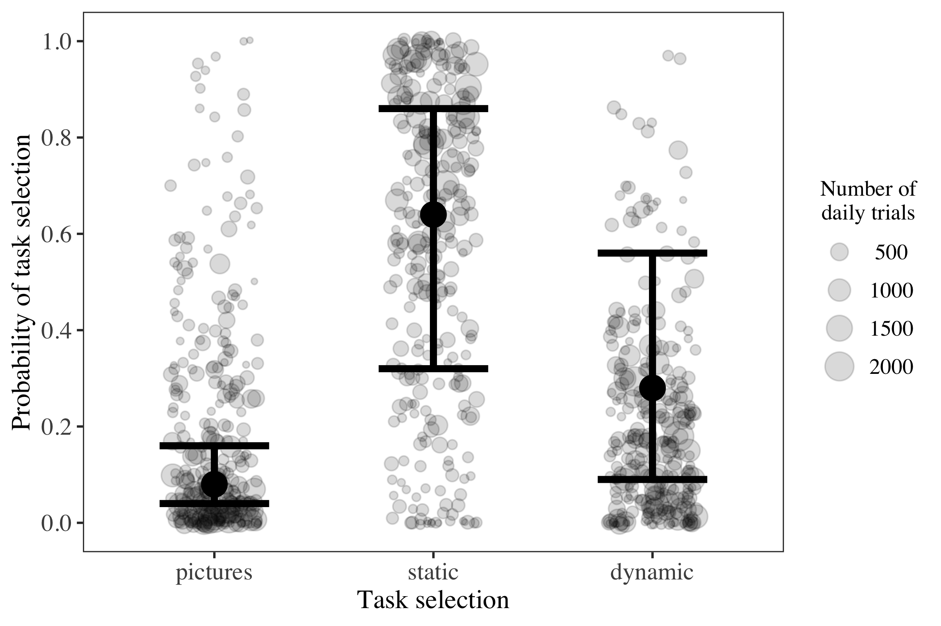
Fig. 1: The monkeys’ overall task selection behavior during the Multiple Choice Interface experiment. Point size reflects the total number of trials conducted by each monkey for each selection, session, and selection position (range: 2 to 2196 trials). The position of each point represents the proportion of trials that the monkey selected the picture, static, or dynamic task. Dark points indicate the model probability estimates. Whiskers represent the 95 % credible intervals. Model probability estimates and credible intervals calculated from a model run with all covariates at their mean and the selection position is set to ‘middle’.
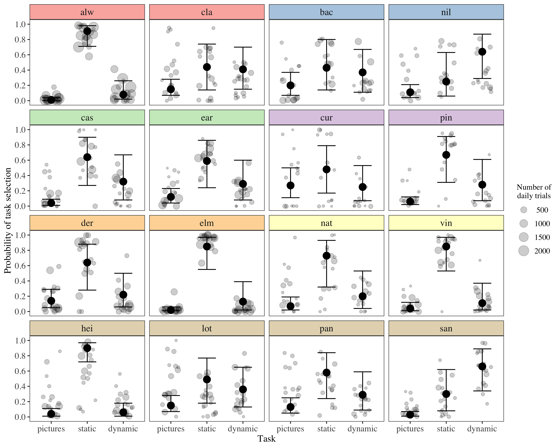
Fig. 2: The task selection behavior for each monkey during the Multiple Choice Interface experiment. Point size reflects the total number of trials conducted by each monkey for each selection, session, and selection position (range: 2 to 2196 trials). The position of each point represents the proportion of trials that the monkey selected the picture, static, or dynamic task. Dark points indicate the model probability estimates. Whiskers represent the 95 % credible intervals. Model probability estimates and credible intervals calculated from a model run with all covariates at their mean and the selection position is set to ‘middle’.
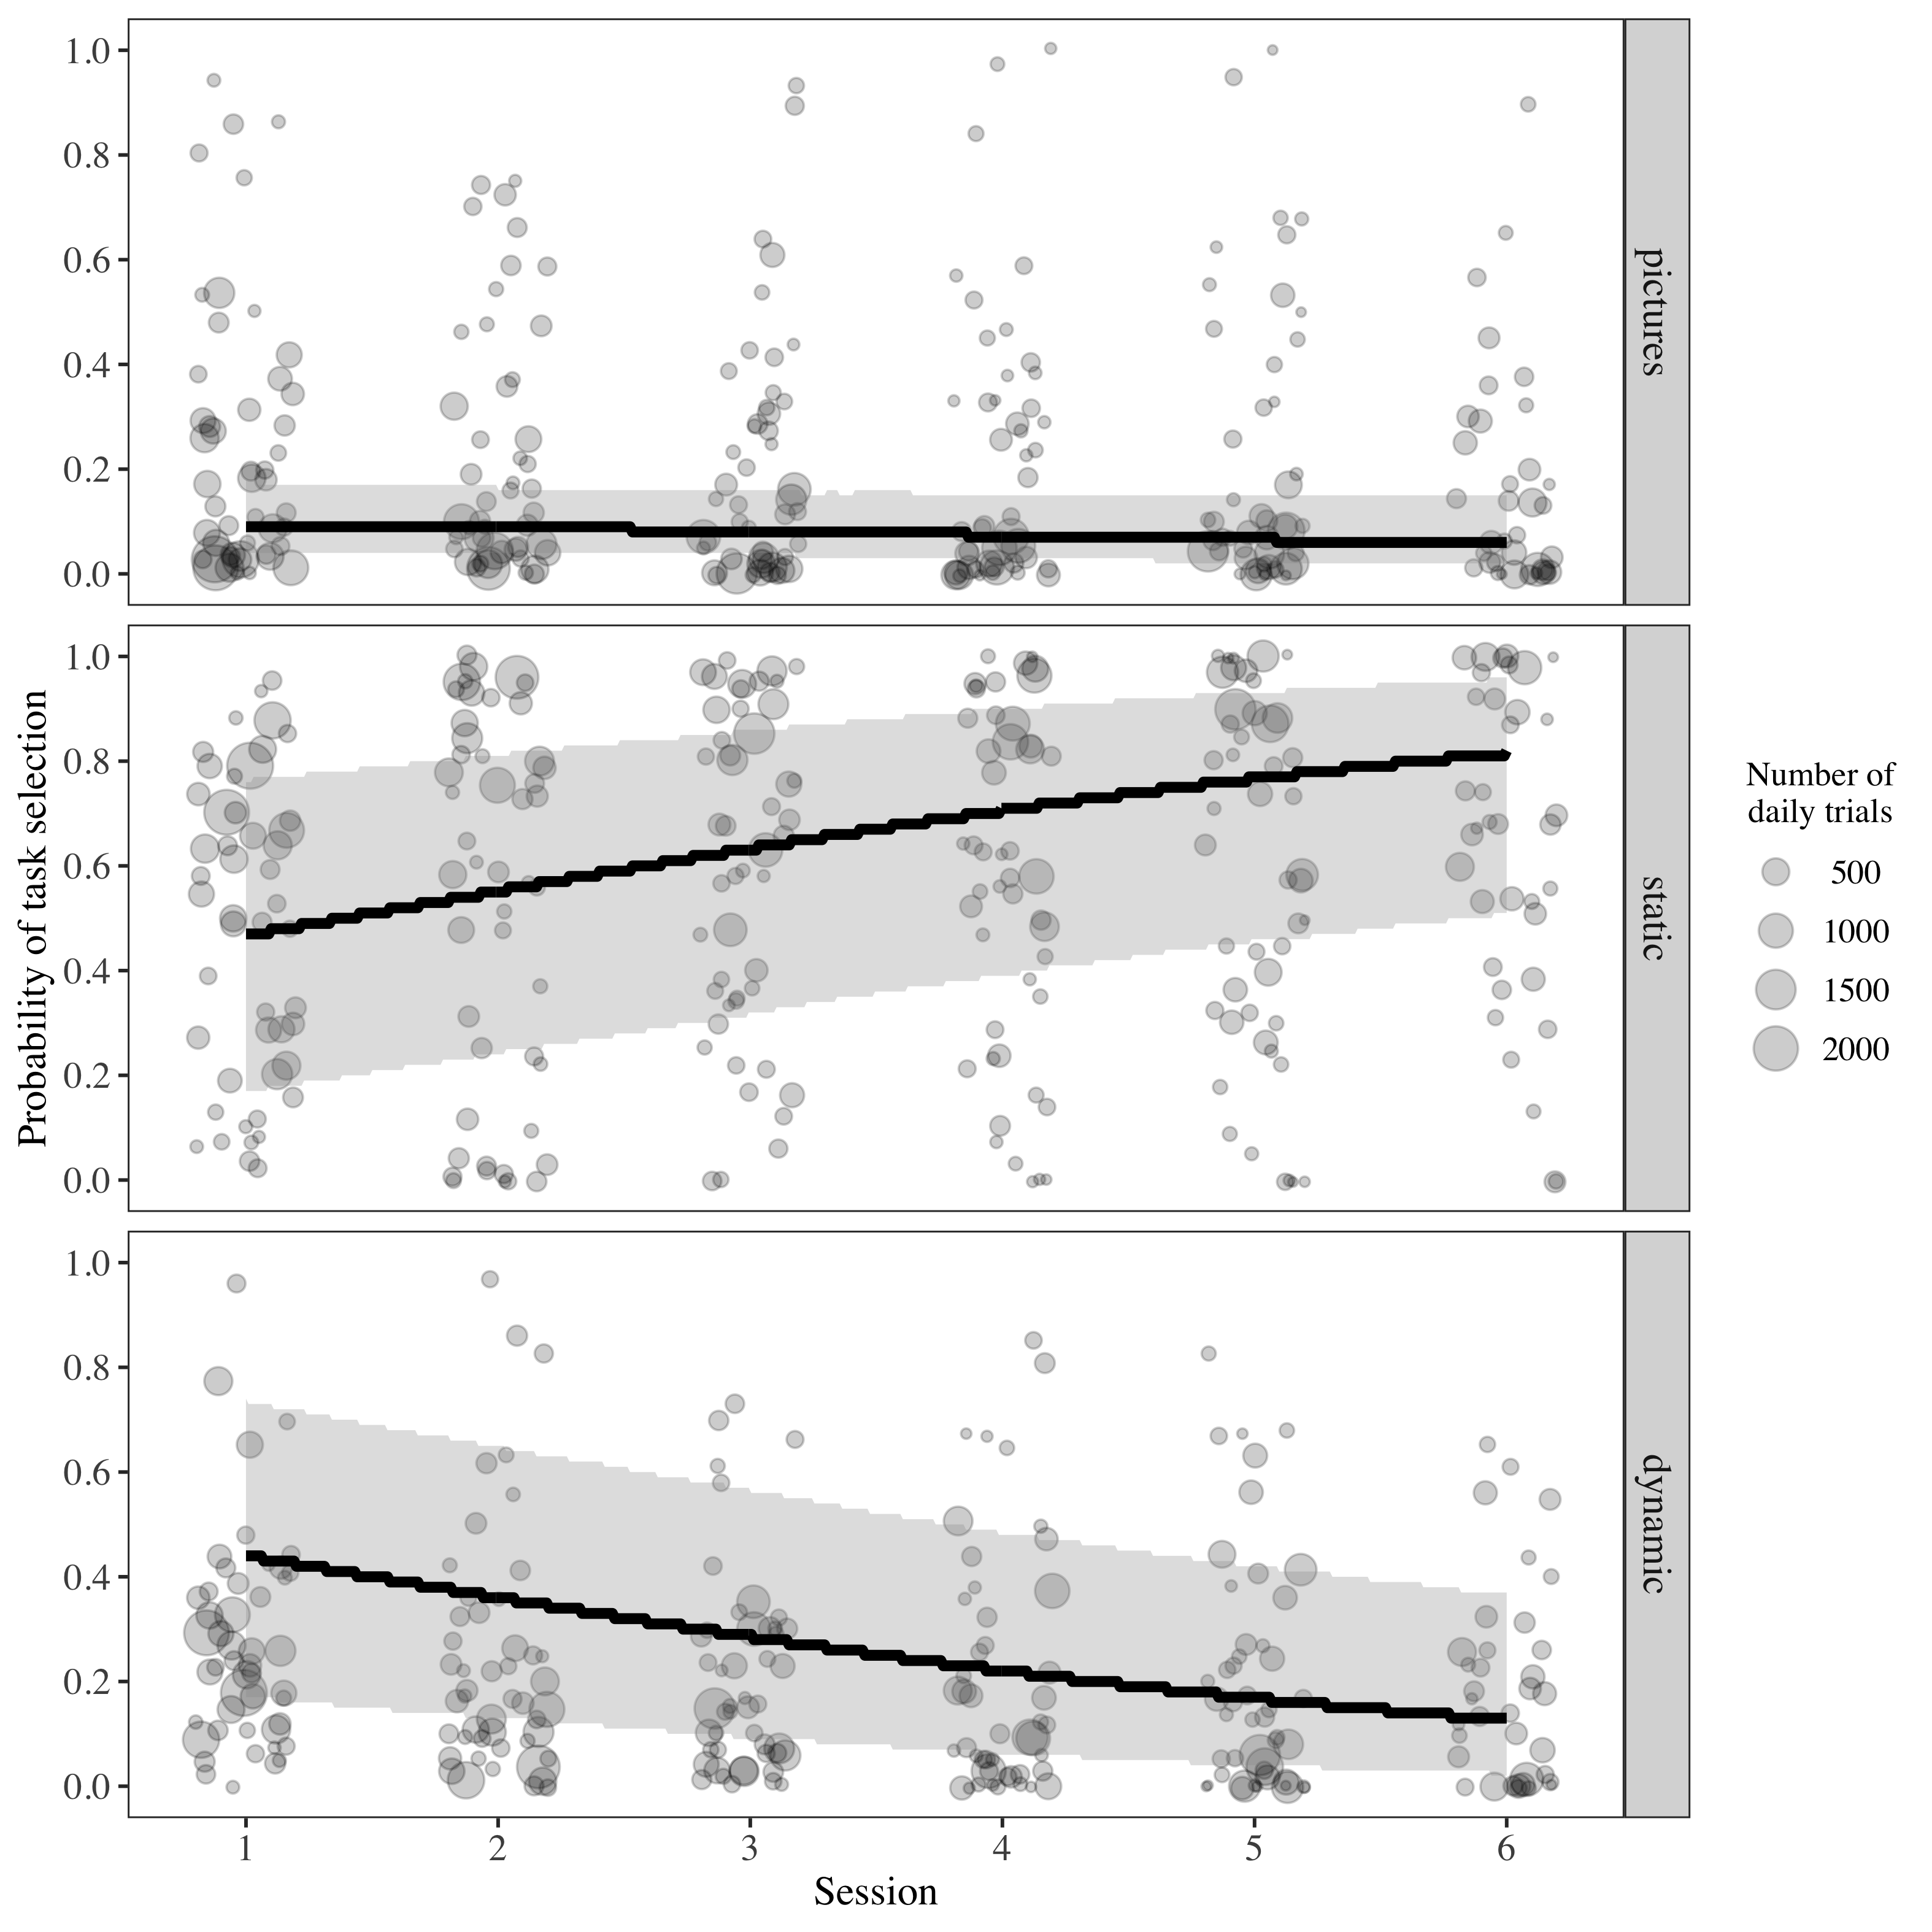
Fig. 3: The effect of session on the monkeys’ task selection behavior in the Multiple Choice Interface experiment. Point size reflects the total number of trials conducted by each monkey for each selection, session, and selection position (range: 2 to 2196 trials). The position of each point represents the proportion of trials that the monkey selected the picture, static, or dynamic task. Dark colored lines indicate the model probability estimates. Light bands represent the 95 % credible intervals. Model probability estimates and credible intervals calculated from a model run with all covariates at their mean and the selection position is set to ‘middle’.
Note: graph needs some work to smoothen out the lines.
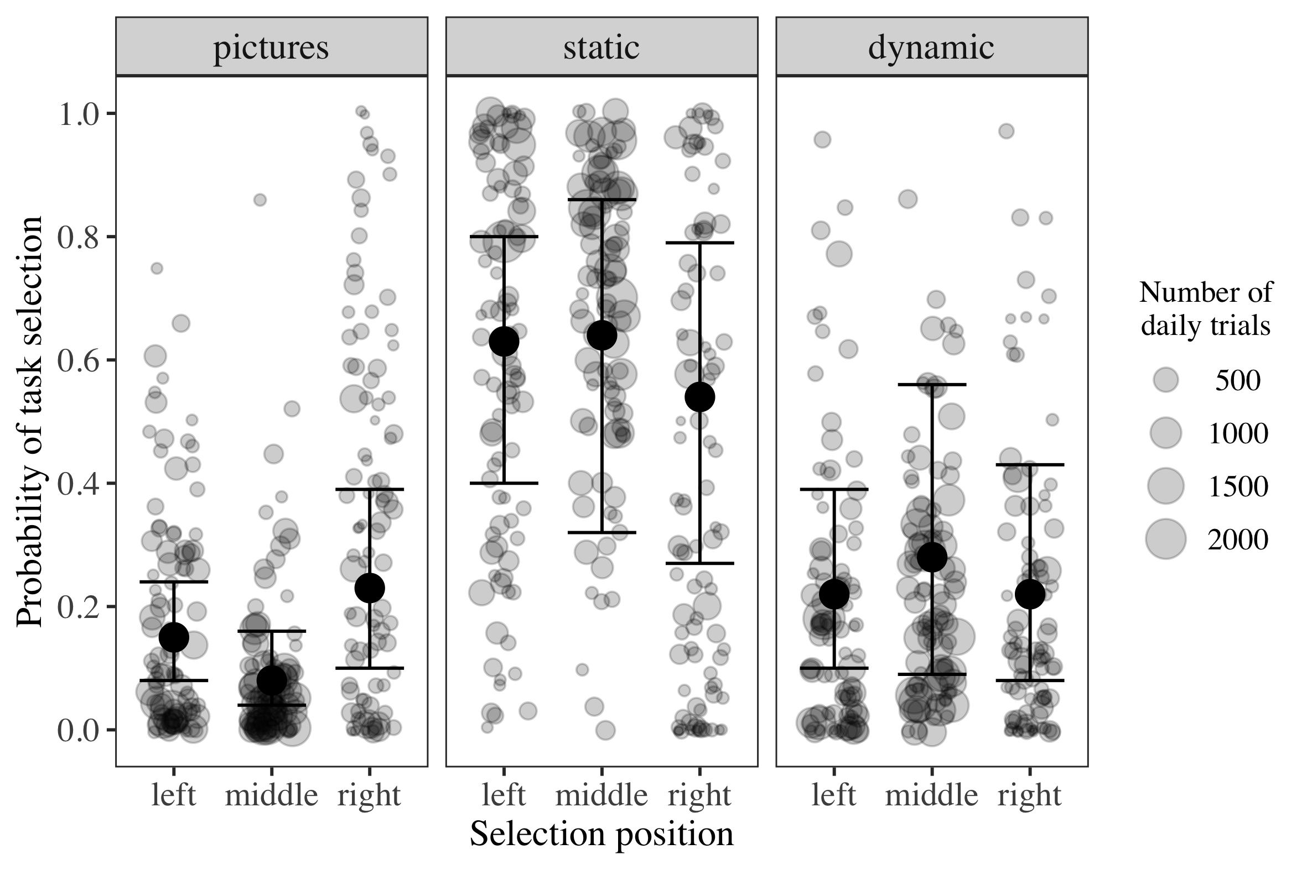
Fig. 4: The effect of stimulus position on task selection behavior in the Multiple Choice Interface experiment. Point size reflects the total number of trials conducted by each monkey for each selection, session, and selection position (range: 2 to 2196 trials). The position of each point represents the proportion of trials that the monkey selected the picture, static, or dynamic task. Dark points indicate the model probability estimates. Whiskers represent the 95 % credible intervals. Model probability estimates and credible intervals calculated from a model run with all covariates at their mean.

Bibliography
Aiken, L. S., West, S. G., and Reno, R. R. (1991). Multiple Regression: Testing and Interpreting Interactions. London, UK: Sage Publications.
Barr, D. J., Levy, R., Scheepers, C., and Tily, H. J. (2013). Random effects structure for confirmatory hypothesis testing: Keep it maximal. Journal of Memory and Language 68(3): 255–278. doi: 10.1016/j.jml.2012.11.001
Bürkner, P.-C. (2017). Brms: An R package for Bayesian multilevel models using Stan. Journal of Statistical Software 80(1): 1–28. doi: 10.18637/jss.v080.i01
McElreath, R. (2020). Statistical Rethinking: A Bayesian Course with Examples in R and Stan (2nd ed.). Boca Raton: Taylor and Francis, CRC Press.
R Core Team. (2021). R: A Language and Environment for Statistical Computing. Vienna, Austria: R Foundation for Statistical Computing. http://www.R-project.org/
Schielzeth, H. (2010). Simple means to improve the interpretability of regression coefficients. Methods in Ecology and Evolution 1(2): 103–113. doi: 10.1111/j.2041-210X.2010.00012.x
Schielzeth, H., and Forstmeier, W. (2009). Conclusions beyond support: Overconfident estimates in mixed models. Behavioral Ecology 20(2): 416–420. doi: 10.1093/beheco/arn145

